How did women get into World War 1?
World War 1 in Australia for many families was extremely painful because many husbands left their families for months on end. In the early part of World War 1, women were never really involved that much. Women at home had to deal with the consequences of the war like the responsibilities of looking after their children and hoping their husbands would not be wounded or killed. Women were also strongly encouraged to join voluntary organisations to help the war effort such as: Australian Red Cross, the Country Women's Association, the Women's Christian Temperance Union, the Australian Women’s National League, the Voluntary Aid Detachment, the Australian Comforts Fund and the Cheer-Up Society.
What did women do in World War 1?
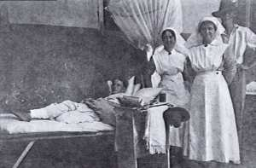
During the World War 1, Australian women were able to join the Australian army and mostly became nurses and medical workers. There were also Red Cross workers in the army to provide comfort to the troops. If women were between the ages of 21-50 and single or widowed they were eligible to join the army. As women took up paid work in jobs that were for the men that had gone to war, there was resistance which lasted into WW2. It was uncommon for many women to have jobs, however jobs did increase during the war in industries such as food, printing and clothing where women were mainly previously employed.

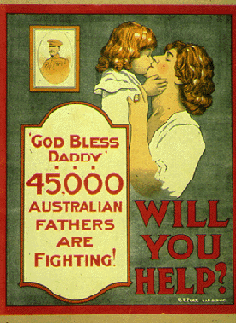
Were women needed at home as well as in the army?
As women were needed to be placed in jobs where men usually worked, they were still largely needed at home with to manage their families. Once you were 18 you were considered to eligible to help out in aid of the war as a volunteer or in jobs where the men used to work before they had gone to war. As men were sent to war, women had to be more involved in the workforce and in 1914 the workforce by women rose 24 per cent. As the per cent rose, the working wages for women decreased. Women were paid up to 54 per cent less than men. In the later years women wanted to be more involved in working in war related activities like cooking for the soldiers, stretcher bearers, motor car drivers and interpreters. There was resistance from the government at that time not wanting to allow women to do these jobs. However a small number of women were employed in some professions such as teaching. Clerical roles and shop assistance roles were also available to some women.

Why were War Bonds sold?
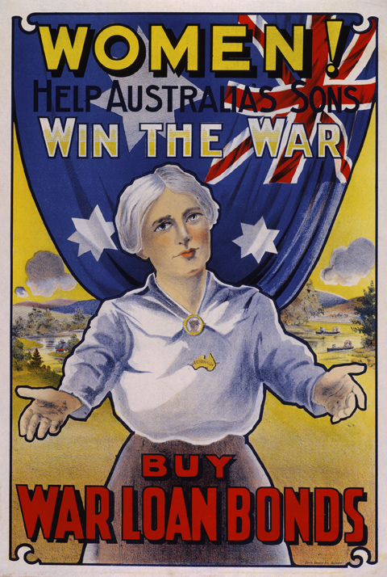
When it was realised the was going to last longer than six months or even a year, Australia like many other countries realised they would need to raise more money to finance the war efforts. So the government developed War Bonds. The War Bonds were an appeal to get citizen’s to lend their money to the government. The bonds were not a very good investment as the return rate offered by the government was below the market rate. These loans were estimated to pay for more than 60 per cent of the war. It was very important to sell as many War bonds as possible. Many women were involved in selling War Bonds. Women were depicted in the posters to encourage families to feel patriotic and have some responsibility to be part of the war.

How are women today different to women in World War 1?
During World War 1, women could not vote and the majority could not even drive a car. They had limited education and were not allowed to work once they were married.
These days many women are enlisted in the Australian armed services. We now see more women working in the Navy, Air Force and the Army. The armed forces now offer a career for women in many diverse roles from administrators to engineers. Women often hold very senior roles.

Please click the Hyperlink to see a poem written on the young men that went to war.
Young Men that went to War

