Sose Assignment
When and why did World War 1 begin?
World War One began in August 1914 and ended on the 11th November 1918 after the Armistice was signed. The main reason why the war started was because of the assassination of Archduke Franz Ferdinand and his wife on the 28th June 1914. World War one cannot be portrayed as successful, this is because thousands of men died and thousands of men returned to their home injured. When the word “injured” is used, it is meant as though half a face has been blown off (as shown in image below), limbs missing, hearing and sight lost and also brain damage.
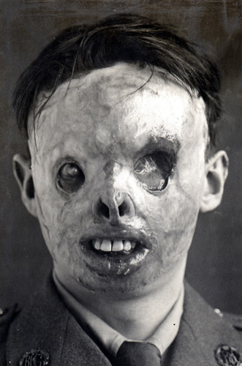

What were the requirements to fight in the war?
To be enrolled in war, for military or fighting services you had to be male and over eighteen, even though many men lied about their age. This meant that women could not fight in war; they were permitted to be nurses or service women making uniforms and clothes for the men. As the war went on, more and more Australian women became lonely at home, meaning that they had to make money for the family, take care of the kids and do all of the household jobs. When the war started it was very rare for women to have jobs, aside from community and domestic services. As the war gradually continued the amount of jobs taken up by women increased, these included food, clothing and printing industry jobs.
Why did women become involved in World War 1?
During the war more men were taken away every day because the troops were running out, simply because they were dying and therefore the amount of usable men for the war was running out. This meant that replacements needed to be made, which lead to the inclusion of women. When women were accepted for war (not necessarily to fight) there was a slight vibe of celebration, because the women were trying to be included the whole time. This was because they were lonely at home, wanting to help the men or were yearning for more information about the war, because the men were not allowed to write the truth in their letters.
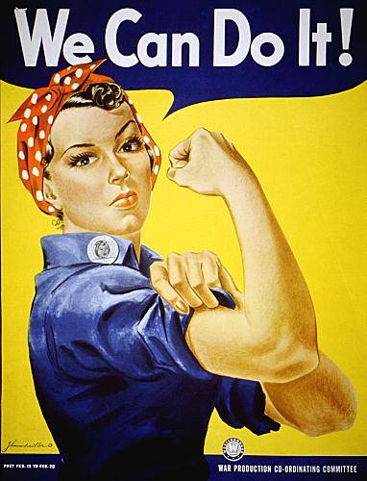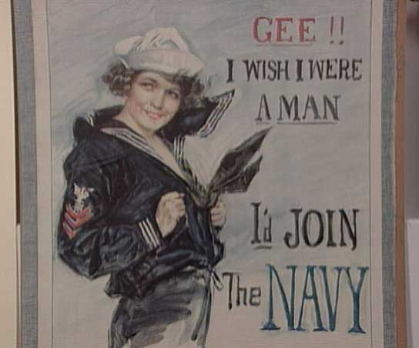
Why wasn’t there much truth in letters from troops?
In world war one there was no such thing as a mobile phone or a computer and therefore the only way of communication over a distance was by letters and mail. Women received letters from their husbands, relatives and boyfriends in the war as often as the men wrote to them, although those letters never had the real facts. This is because all the letters had to be checked and read through, so that they made sure that no secret information was being sent around. Because the men weren’t allowed to say much truth in there letters, the women receiving the letters became curious and wanted to know what was really happening to their husbands, boyfriends and relatives. This created a lot of interest for the women and decided that to get information, they had to get into the war, whether that meant to be making things for the men, being nurses, cooking or even fighting in the war. So from then on women were creating posters and trying to form groups that would help get them involved in world war one.
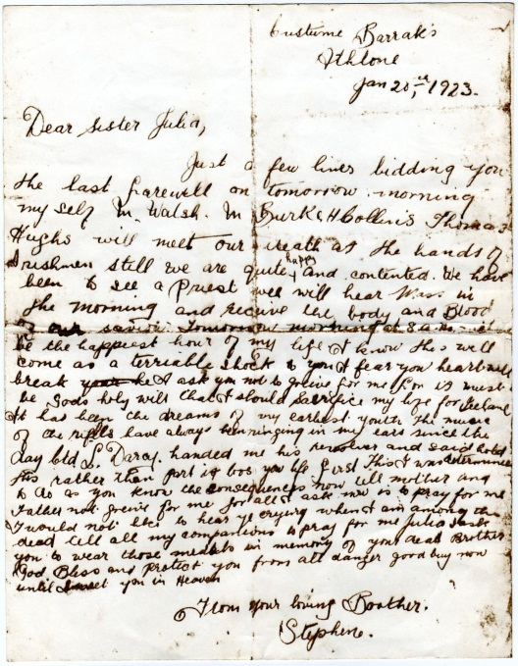
Who were some important women in World War 1?
There were a few important women in world war one, who have achieved some great things for all of the other women who wanted to be involved in the war. A lady of the name Loretta Perfectus Walsh is a great example of this because she was the first women to become an active-duty navy women working in a non-nurse occupation in 1917. She had a great influence on women and created ideas of ways to get into the war.
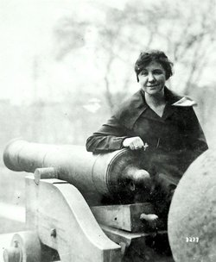

What was the role of women at home in World War 1?
When the war started many women had trouble looking after their families, as most of their husbands and fellow males weren’t there to help. This meant that they had to get jobs, as well as the average household duties, for example washing the clothes, making dinner and taking care of children, so that there was enough money for the family to survive on. As the war went on, women jobs were running out and men were needed for jobs which were only run by men, so eventually women enrolled for jobs which were out of traditional gender expectations. The work average for food, clothing and printing industries started to increase throughout war time, because so many women were getting jobs.
